A FIELD PROJECT REPORT

on

**“Movie Recommendation System With Machine Learning”**

**Submitted**

221FA04442

Venkata Reddy

221FA04483

Rama krishna

221FA04480

Dhanya Sri

221FA04626

Sai Devendra

**Under the guidance of**

### Dr. S. Deva Kumar

*Designation*



**DEPARTMENT OF COMPUTER SCIENCE & ENGINEERING VIGNAN'S FOUNDATION FOR SCIENCE, TECHNOLOGY AND RESEARCH Deemed**

**to be UNIVERSITY**

**Vadlamudi, Guntur.**

**ANDHRA PRADESH, INDIA, PIN-522213.**



**CERTIFICATE**

This is to certify that the Field Project entitled **“Movie Recommendation System With Machine Learning”** that is being submitted by 221FA04442 (Venkata Reddy), 221FA04480 (Dhanya sri), 221FA04483(Ramakrishna) and 221FA04626(Devendra) for partial fulfilment of Field Project is a bonafide work carried out under the supervision of Ms. Dr. N. Sameera., Assistant Professor, Department of CSE.



Guide name& Signature Dr.K.V. Krishna Kishore

Assistant/Associate/Professor, CSE

HOD,CSE Dean, SoCI



**DECLARATION**

We hereby declare that the Field Project entitled “**Movie Recommendation System With Machine Learning”** that is being submitted by 221FA04442 (Venkata Prakesh), 221FA04480(Dhnaya Sri), 221FA04483 (Rama krishna) and 221FA04626 (Devendra) in partial fulfilment of Field Project course work. This is our original work, and this project has not formed the basis for the award of any degree. We have worked under the supervision of Ms. Dr.

N. Sameera., Assistant Professor, Department of CSE.

By

**221FA04442 (Venakata Reddy), 221FA04480(Dhanya Sri),**

**221FA04483(Ramakrishna),**

**221FA04626(Devendra)**

**ABSTRACT**

A movie recommendation system is a cutting-edge tool that personalizes the way users discover films, transforming vast movie libraries into curated collections tailored to individual preferences. By analyzing user behavior, preferences, and movie attributes, the system intelligently predicts and suggests films that users are most likely to enjoy. Leveraging advanced machine learning algorithms, including collaborative filtering, content-based filtering, and hybrid models, the system evolves with user interactions, offering increasingly accurate and diverse recommendations over time.

This system addresses critical challenges such as data sparsity, the cold start problem for new users or movies, and the need for real-time performance on large-scale platforms. It not only enhances user engagement by delivering relevant content but also supports the discovery of diverse and lesser-known films. By balancing accuracy, novelty, and diversity, the system offers an enjoyable and dynamic viewing experience.

Moreover, the integration of ethical practices—like minimizing bias, protecting user privacy, and promoting fairness—ensures a responsible and sustainable recommendation process. Ultimately, a movie recommendation system not only boosts user satisfaction but also helps platforms increase retention and engagement, making it a powerful tool for both audiences and businesses in the entertainment industry.

**TABLE OF CONTENTS**

1. Introduction 
   1. Background and Significance of Movie Recommendation System
   2. Overview of Machine Learning in Movie Recommendation System
   3. Research Objectives and Scope
   4. Current Challenges in Movie Recommendation System
   5. Applications of ML to Movie Recommendation System
2. Literature Survey 
   1. Literature review
   2. Motivation
3. Proposed System 
   1. Input dataset

3.1Detailed features of dataset

* 1. Data Pre-processing
  2. Model Building
  3. Methodology of the system
  4. Model Evaluation
  5. Constraints
  6. Cost and Sustainability Impact

1. Implementation 
   1. Environment Setup
   2. Sample code for preprocessing and MLP operations
2. Experimentation and Result Analysis
3. Conclusion
4. References

**LIST OF FIGURES**

Figure 1. Architecture of the proposed system

Figure 2. Various features in the dataset after Pre-Processing

Figure 3. Training Vs Testing Accuracy

Figure 4. Confusion Matrix

Figure 5. Performance Outcomes

Figure 6. ROC Curve for Each Class

Figure 7. Logistic Regression-Confusion Matrix

Figure 8. Naïve Bayes-Confusion Matrix

Figure 9. Support Vector Machine (SVM) -Confusion Matrix

Figure 10. Random Forest-Confusion Matrix

Figure 11. XGBoost -Confusion Matrix

Figure 12. Decision Tree Visualization

Figure 13. Confusion Matrix for MLP Model

**LIST OF TABLES**

Table 1. Table 1. Recorded Results for each Classifier

**CHAPTER-1 INTRODUCTION**

# INTRODUCTION

**1.1 Background and Significance of Movie Recommendation**

Movie recommendation systems have become a cornerstone of modern streaming platforms, playing a vital role in helping users navigate the ever-growing library of digital content. As streaming services continue to expand, the sheer volume of movies, TV shows, and documentaries available can overwhelm users, leading to what is commonly referred to as the "paradox of choice." This phenomenon describes how too many choices often make decision-making harder rather than easier. Users faced with thousands of options may find it difficult to select content that aligns with their preferences, leading to frustration and disengagement.

Recommendation systems address this issue by offering **personalized suggestions** based on various factors such as viewing history, user preferences, and demographic information. These systems use advanced algorithms and machine learning models to analyze a user's behavior, including their past interactions with the platform, liked genres, and even the types of actors and directors they prefer. By leveraging this data, recommendation systems present users with content that matches their interests, thereby reducing the effort required to find something worth watching.

The Role of Recommendation Systems in Enhancing User Experience

The user experience is significantly improved by an effective recommendation system. A well-designed system allows users to discover new content that they might have otherwise overlooked, introducing them to movies or shows that align with their tastes but are outside their usual consumption patterns. For example, if a user frequently watches action movies, a recommendation system might suggest related genres like thrillers or sci-fi films, expanding their horizons while still catering to their core interests. This not only adds variety but also helps users break out of content bubbles, making the platform more engaging and dynamic.

Moreover, personalized recommendations save time. Rather than scrolling endlessly through large libraries of movies and shows, users are presented with curated lists of content that are highly relevant to them. This efficiency in content discovery enhances the platform's usability, making it feel more intuitive and user-friendly. For platforms, a seamless and enjoyable user experience translates into **longer viewing times**, increased user engagement, and, ultimately, **higher customer retention rates**.

Economic Impact and Competitive Advantage

From an economic standpoint, recommendation systems are a critical driver of revenue for streaming platforms. Platforms like Netflix, Hulu, and Amazon Prime depend heavily on **user engagement** to maintain their subscriber base, as higher engagement often leads to **subscription renewals** and **reduced churn** (the rate at which users unsubscribe). When users are satisfied with the content being recommended to them, they are more likely to stay on the platform, explore more content, and renew their subscriptions, thus contributing to the platform’s long-term profitability.

Additionally, recommendation systems allow streaming platforms to **optimize their content investments**. By analyzing the types of movies and shows that different user segments prefer, platforms can make more informed decisions about what content to acquire or produce. For instance, if a recommendation system identifies a strong demand for a particular genre, the platform can invest in producing original content in that genre, increasing its chances of success. This data-driven approach helps platforms reduce the risk associated with content investments and ensures that they are catering to their audience's preferences.

Personalized recommendations also play a crucial role in increasing the visibility of **niche or less popular content**. While blockbuster movies and popular series may naturally attract attention, smaller independent films, documentaries, or international content may struggle to reach a wider audience. Recommendation systems help bridge this gap by promoting these lesser-known titles to users who are likely to appreciate them. This not only benefits the platform by increasing the overall diversity of content consumed but also supports filmmakers and creators who produce non-mainstream content.

Retention and Loyalty in a Competitive Market

In the highly competitive streaming market, where platforms are constantly vying for users’ attention, a robust recommendation system can be a key differentiator. Companies like Netflix and Amazon Prime have invested heavily in developing **sophisticated recommendation engines** that leverage machine learning, artificial intelligence, and data analytics to provide highly accurate, real-time recommendations. By offering a personalized experience that feels tailored to each user, these platforms create a sense of loyalty and make it less likely that users will switch to competing services.

In fact, studies show that the quality of recommendations can be a deciding factor in whether a user remains subscribed to a platform. A poor recommendation system that suggests irrelevant or low-quality content may frustrate users and cause them to look for alternative platforms. Conversely, a system that consistently offers high-quality, relevant recommendations can build trust and encourage users to rely on the platform as their go-to source for entertainment.

The integration of **user feedback loops** also enhances retention. For example, platforms that allow users to rate movies, like or dislike content, or provide reviews can feed this data back into the recommendation engine to further refine its suggestions. This creates a dynamic system where user preferences are continuously updated, and the platform becomes more personalized over time, increasing its value to the user.

The Future of Recommendation Systems: Seamless Content Discovery Across Services

As media consumption becomes increasingly fragmented, with users subscribing to multiple services simultaneously (e.g., Netflix, Disney+, Amazon Prime), **content discovery across platforms** is becoming more complex. Users often have to switch between services to find something to watch, which can be time-consuming and disrupt the overall viewing experience. In response, there is growing interest in developing **cross-platform recommendation systems** that can suggest content from multiple services, creating a more seamless and unified content discovery experience.

**1.2 Overview of Machine Learning in Movie Recommendation**

Machine learning has fundamentally transformed the way recommendation systems operate, making them far more intelligent, flexible, and capable of dealing with large volumes of data. By enhancing traditional recommendation techniques such as collaborative filtering and content-based filtering with machine learning, systems can provide more personalized, accurate, and dynamic recommendations. This shift is particularly significant given the massive datasets now available to streaming platforms and e-commerce services, which traditional methods struggle to handle efficiently.

Traditional Methods and Their Limitations

- **Collaborative Filtering**: Collaborative filtering is one of the most widely used methods for recommendation systems. It operates on the principle that users who have shared similar preferences in the past are likely to continue doing so in the future. The two main types of collaborative filtering are:

- **User-based Collaborative Filtering**: This method recommends items to a user based on what similar users have liked. For instance, if User A and User B have both liked several of the same movies, User A will be recommended movies that User B has liked but User A hasn’t watched yet. However, this approach can struggle when there are too many users, as the system must compare each user to many others, which can lead to scalability issues.

- **Item-based Collaborative Filtering**: Instead of comparing users, this method compares items directly. For example, if a user likes a specific movie, they will be recommended movies that are similar to that one, based on the preferences of users who also liked the same movie. This method can sometimes be more efficient than user-based filtering but still has its own limitations, particularly with the "cold-start problem," where there isn’t enough data on new users or new items for the system to make meaningful recommendations.

Despite its usefulness, collaborative filtering has several notable challenges:

- **Cold-Start Problem**: When a new user joins the platform or a new movie is added to the database, there isn’t enough data about the user’s preferences or about how others feel about the movie. This makes it difficult for the system to provide recommendations, as collaborative filtering relies on historical data to make predictions.

- **Scalability**: As the number of users and items grows, collaborative filtering systems become less efficient. The computation required to compare users or items increases exponentially, which can slow down the recommendation process.

- **Data Sparsity**: In large datasets, most users will have rated only a small subset of the available movies. This creates a sparse user-item interaction matrix, making it challenging to find significant patterns between users and items.

- **Content-based Filtering**: Unlike collaborative filtering, which relies on user preferences, content-based filtering focuses on the attributes of the items themselves. For movie recommendations, this could include factors such as genre, actors, directors, and plot descriptions. The system builds a profile for each user based on the features of the movies they’ve watched and liked. It then recommends new movies with similar characteristics.

This approach has the advantage of being able to recommend items even when a user hasn’t interacted much with the system, making it useful for addressing the cold-start problem. However, content-based filtering has its own limitations:

- **Lack of Diversity**: Content-based systems often provide narrow recommendations that are too similar to the items the user has already consumed. For example, if a user watches only action movies, the system may continue recommending only action movies, which limits the discovery of new genres.

- **Overfitting**: The system may become too focused on specific characteristics of the items, recommending movies that match the user’s exact preferences but missing other potentially interesting options outside those preferences.

Machine Learning Enhancements

Machine learning significantly enhances these traditional methods by enabling systems to learn from data, adapt to user behavior, and scale more effectively. Several machine learning techniques have been incorporated into recommendation systems to address the limitations of collaborative and content-based filtering.

- **Matrix Factorization**: One of the most powerful techniques used in modern recommendation systems is matrix factorization, which addresses the data sparsity issue of collaborative filtering. Matrix factorization models decompose the user-item interaction matrix (where users' ratings for items are stored) into two lower-dimensional matrices: one representing users and the other representing items. This helps uncover latent factors that explain the observed user preferences.

- **Singular Value Decomposition (SVD)**: This technique is one of the most well-known matrix factorization methods. SVD became popular through the Netflix Prize competition, where the challenge was to improve the accuracy of the company's recommendation algorithm. By breaking down the user-movie matrix into latent factors, SVD identifies hidden patterns that explain why certain users prefer certain movies. For example, a latent factor might represent a preference for action movies, and the algorithm can predict which users will like action movies based on how strongly they align with this latent feature.

Matrix factorization methods have greatly improved recommendation systems' ability to handle large datasets, providing more accurate predictions and addressing the scalability issues of traditional collaborative filtering. Additionally, they can handle sparse data more effectively by filling in the gaps in the user-item interaction matrix.

- **Neural Networks**: The rise of deep learning has introduced more sophisticated models into the realm of recommendation systems. Neural networks, particularly deep learning architectures, can process massive amounts of data and identify complex relationships between users and items that traditional algorithms may miss.

- **Autoencoders**: An autoencoder is a type of neural network used for unsupervised learning, where the system tries to learn an efficient representation of the data. In recommendation systems, autoencoders can be used to predict missing ratings in the user-item matrix by learning a compressed representation of user preferences.

- **Convolutional Neural Networks (CNNs)**: While CNNs are typically associated with image processing, they have been adapted for use in recommendation systems to analyze unstructured data, such as movie posters or trailers. By extracting features from visual data, CNNs can enhance the content-based filtering process and improve recommendations based on the visual attributes of movies.

- **Recurrent Neural Networks (RNNs)**: RNNs are particularly useful for capturing sequential data and temporal dynamics, making them effective in recommendation systems where user preferences evolve over time. For example, a user may prefer action movies one month and switch to comedies the next. RNNs can track these changing preferences and adjust recommendations accordingly.

- **Natural Language Processing (NLP)**: Machine learning models can also incorporate natural language processing techniques to analyze user reviews, comments, and movie descriptions. By understanding the sentiment and meaning behind user-generated text, recommendation systems can better capture users’ preferences and fine-tune recommendations. For example, sentiment analysis can detect whether a user enjoyed or disliked a specific movie, providing additional data points for the recommendation algorithm.

**1.3 Research Objectives and Scope**

The primary objectives of this research should focus on addressing key challenges and gaps in current movie recommendation systems. As recommendation engines are integral to enhancing user experience and driving engagement, identifying areas for improvement is crucial. Here are several objectives that could form the foundation of your research:

1. **Improving Accuracy**

One of the core objectives of movie recommendation systems is to predict user preferences with greater accuracy. Traditional methods like collaborative filtering and content-based filtering, while useful, often fall short in complex environments where users’ tastes are diverse and evolving. The research aims to develop a model that outperforms traditional algorithms by incorporating advanced techniques such as machine learning, matrix factorization, and neural networks. A key focus could be on **hybrid models** that combine the strengths of multiple approaches to make more precise predictions. For instance, using collaborative filtering to identify user similarity, while complementing it with content-based methods to assess the specific features of movies, could lead to a more accurate recommendation.

- **Objective**: Design and evaluate hybrid models that can predict user preferences with a higher degree of accuracy by considering both user behavior and content characteristics, while also accounting for evolving preferences over time.

2. **Cold-Start Solutions**

The **cold-start problem** is one of the most significant challenges in recommendation systems. New users or new items (movies, in this case) do not have enough historical data to make accurate predictions, leading to irrelevant or generic recommendations. This research will focus on **addressing the cold-start issue**, by exploring methods that allow the system to recommend movies even when little or no prior data exists for a user or movie. One potential solution involves leveraging **metadata** (such as genre, cast, or director information) along with **social media activity, demographic data, or user-provided preferences** at the time of sign-up. Additionally, incorporating sentiment analysis from reviews and social media discussions could help generate early recommendations.

- **Objective**: Develop algorithms that minimize the cold-start problem by incorporating external data such as social media, demographics, or user input to make meaningful recommendations even with limited user history.

3. **Real-Time Recommendations**

Another key research objective is to explore ways to make recommendation systems more dynamic by integrating **real-time data**. Traditional recommendation systems often rely on static data, which may not reflect a user's current preferences. By incorporating real-time user activity—such as what a user recently watched, liked, or interacted with—the system could become more responsive to immediate preferences and trends. This would enable the platform to offer more relevant, timely recommendations, thereby enhancing user satisfaction.

- **Objective**: Investigate methods for integrating real-time user data into recommendation systems to create dynamic models that can adapt to changing user behavior on-the-fly, offering more relevant suggestions in real-time.

4. **Hybrid Approaches**

Hybrid recommendation systems, which combine the strengths of **collaborative filtering, content-based filtering, and other data-driven approaches**, can offer a more robust solution to the limitations of traditional algorithms. This research could focus on exploring different **hybrid techniques** that leverage both user-based and item-based data, while incorporating machine learning models such as deep neural networks or reinforcement learning. For example, a hybrid system could first use collaborative filtering to generate an initial set of recommendations and then refine this list by analyzing the content features of the movies that the user has shown interest in.

- **Objective**: Explore and develop hybrid recommendation systems that combine multiple methods (e.g., collaborative filtering, content-based filtering, matrix factorization) to provide more accurate, flexible, and personalized recommendations.

5. **Diversity in Recommendation**

While accuracy is important, focusing solely on it can sometimes result in narrow recommendations that repeatedly suggest similar types of movies. Encouraging **diversity** in recommendations allows users to explore new genres, themes, or less popular films, enriching their overall experience. A system that occasionally introduces movies outside a user’s usual preferences may enhance discovery and expand user engagement. The research could explore how to develop algorithms that strike a balance between recommending content that the user is likely to enjoy and offering diverse suggestions that push the boundaries of their typical viewing habits.

- **Objective**: Design models that provide a balance between personalization and diversity, encouraging users to explore content outside their usual preferences while still delivering relevant recommendations.

6. **User Engagement and Behavior**

Effective recommendation systems have a direct impact on user behavior and engagement. By studying how personalized recommendations influence user actions—such as increased viewing time, higher satisfaction levels, or reduced platform churn—this research can offer insights into how to improve both user experience and platform performance. Additionally, understanding how recommendation systems affect user loyalty and retention could guide the development of more strategic, user-centered algorithms.

- **Objective**: Study the correlation between recommendation system effectiveness and user engagement, aiming to develop models that not only improve viewing time and satisfaction but also reduce user churn by offering engaging, personalized experiences.

Research Scope

The scope of this research will cover both **theoretical advancements** and **practical implementations** in movie recommendation systems. This involves a combination of **algorithmic development, system design, and evaluation** to ensure that the proposed models are both scientifically robust and practically applicable. The research will focus on improving key aspects of recommendation systems, such as accuracy, handling of the cold-start problem, diversity, and real-time adaptability. Additionally, the research will include **case studies, prototype systems, and performance evaluations** to demonstrate the real-world applicability and effectiveness of the proposed models.

Theoretical Scope:

- **Algorithm Development**: The research will focus on developing new or improved algorithms, particularly hybrid models, that address specific challenges in movie recommendation systems. This includes matrix factorization techniques, machine learning algorithms (such as neural networks or deep learning models), and hybrid approaches that integrate collaborative filtering and content-based filtering with external data sources.

- **Behavioral Insights**: Studying user behavior in response to different recommendation methods will be a key focus, as the research will explore how effective recommendations can improve user retention, satisfaction, and engagement.

Practical Scope:

- **Prototype Implementation**: The research will include the development of a prototype recommendation system to test the proposed models. This could involve building a **proof-of-concept system** that simulates real-world scenarios using existing movie datasets, allowing the system to generate recommendations based on real user data.

- **Case Studies**: Case studies from existing platforms (e.g., Netflix, Amazon Prime, Hulu) may be analyzed to understand the strengths and weaknesses of current recommendation systems and identify areas for improvement. This could include detailed performance evaluations of different recommendation methods in specific user segments or contexts.

- **Evaluation Metrics**: The research will utilize common evaluation metrics for recommendation systems, such as **precision, recall, F1 score, and diversity metrics**, to assess the effectiveness of the proposed models. In addition to these standard metrics, user-centric metrics like **click-through rate (CTR)**, **watch time**, and **user retention rates** will be examined.

**Conclusion**

This research aims to bridge the gap between traditional recommendation systems and modern, more advanced models by addressing key challenges such as improving accuracy, overcoming cold-start problems, incorporating real-time data, and encouraging diversity in recommendations. By combining theoretical advancements in algorithms with practical applications, this research seeks to create more effective and engaging movie recommendation systems that not only improve user satisfaction but also drive better business outcomes for platforms. The end goal is to offer a more seamless and personalized content discovery experience for users while optimizing platform performance in a competitive, data-driven market.

**1.4 Current Challenges in Movie Recommendation**

Despite their widespread utility and success, movie recommendation systems face several persistent challenges that limit their effectiveness. Addressing these challenges is crucial for improving user experience, ensuring fairness, and maintaining scalability as platforms grow. Here are some of the most significant challenges:

1. Cold-Start Problem

The **cold-start problem** occurs when the system lacks sufficient data to make accurate recommendations. This is especially problematic for new users, who haven’t yet provided enough data (such as viewing history or ratings), and for newly added movies, which haven’t accumulated enough user interactions. Traditional recommendation methods, like collaborative filtering, rely heavily on user-item interaction data, making them less effective in cold-start scenarios.

Potential Solutions:

- **Meta-Learning**: This approach involves training models on tasks that teach the system to generalize from limited data. By leveraging knowledge from similar users or content, the system can make educated guesses about what a new user might like.

- **Side Information**: Using additional data, such as movie genres, cast, director, or release year, helps to create recommendations even when user data is scarce. By analyzing the attributes of a movie, the system can make recommendations based on similarities to other movies the user has enjoyed.

- **User Input**: Requesting explicit input from new users in the form of preferences or ratings during account creation can help mitigate cold-start issues. Some systems ask users to rate a few movies or genres to quickly gather initial data.

Despite these solutions, the cold-start problem remains challenging because side information and meta-learning techniques still rely on assumptions that may not always hold true for every user or movie.

2. **Scalability**

As the size of user bases and content libraries grows, the volume of data that needs to be processed increases exponentially. For large streaming platforms like Netflix or Amazon Prime, scaling the recommendation system to handle millions of users and thousands of new movies every day is a daunting task. The need to compute real-time recommendations across such vast datasets places a strain on computational resources.

**Potential Solutions**:

- **Distributed Computing**: By distributing the computational load across multiple servers or nodes, platforms can handle larger datasets more efficiently. Technologies such as Hadoop and Apache Spark are often employed to enable parallel processing, allowing the system to scale without compromising performance.

- **Parallel Processing**: Parallelizing recommendation algorithms, especially matrix factorization or neural networks, can improve speed and efficiency. By breaking down large computations into smaller, manageable tasks, systems can deliver recommendations in real time without overwhelming computational resources.

- **Approximation Algorithms**: These algorithms can trade off some accuracy for increased speed, which is essential when dealing with huge datasets. Techniques like **approximate nearest neighbors** help in providing faster recommendations by limiting the number of comparisons made during the recommendation process.

However, maintaining both scalability and accuracy remains a complex challenge, especially as datasets continue to grow, requiring constant optimization of these systems.

3. **Diversity vs. Accuracy**

One of the core goals of a recommendation system is to provide personalized, accurate recommendations. However, systems optimized for accuracy often run into the problem of **limited diversity**. When the system continuously recommends content that closely aligns with a user's previous preferences, it can create a feedback loop where users are only exposed to a narrow range of movies or genres. While this improves short-term satisfaction, it limits content discovery and can reduce long-term engagement by not introducing users to new or unexpected options.

**Potential Solutions**:

- **Diversity-Promoting Algorithms**: These algorithms introduce a broader variety of recommendations, even at the expense of accuracy. By injecting random or less common items into the recommendation list, users are more likely to discover new genres, directors, or actors.

- **Hybrid Models**: Combining accuracy-focused algorithms (like collaborative filtering) with content-based or knowledge-based systems can improve diversity. For example, content-based systems can suggest movies with different themes or styles while still considering user preferences.

- **Serendipity Metrics**: Serendipity measures how unexpected and delightful a recommendation is for the user. By optimizing for serendipity, recommendation systems can offer suggestions that users wouldn't have found on their own, adding value to the experience.

The trade-off between accuracy and diversity is a persistent issue. While users want personalized recommendations, they also benefit from being exposed to fresh and diverse content. Striking the right balance is crucial for improving engagement and user satisfaction.

4. **Bias and Fairness**

Recommendation systems, like many machine learning models, are vulnerable to **bias**. Bias can manifest in various ways, such as favoring movies from specific studios, featuring popular actors, or promoting particular genres, often at the expense of lesser-known content. This can limit users’ exposure to more diverse or independent films, reinforcing existing inequalities in content visibility.

**Potential Solutions**:

- **Fairness-Aware Algorithms**: Fairness-aware machine learning algorithms are being developed to address the issue of biased recommendations. These algorithms aim to ensure that all content is given a fair chance of being recommended, regardless of its popularity or commercial backing.

- **De-biasing Techniques**: By using techniques that specifically account for underrepresented content or penalize overrepresented items, the system can create more equitable recommendation lists.

- **Diversity Metrics**: Measuring diversity in recommendations and optimizing for a balance between popular and niche content can help mitigate biases. Some platforms may also implement user feedback loops that identify and correct bias in the system.

Bias is a growing concern as recommendation systems become more influential in shaping user behavior and consumption. Ensuring fairness without sacrificing performance is a complex and evolving challenge.

5. **Overfitting to User Data**

Machine learning models, especially complex ones like deep neural networks, are prone to **overfitting**—where the model becomes too tailored to the existing data and fails to generalize to new data. In the context of recommendation systems, overfitting can result in overly specific recommendations that do not account for shifts in user preferences or emerging content trends. This can stifle user exploration and make the system less adaptable to changes in viewing behavior.

**Potential Solutions**:

- **Regularization Techniques**: Regularization methods like **dropout** or **L2 regularization** can help prevent overfitting by simplifying the model and avoiding reliance on specific data points.

- **Cross-Validation**: Employing cross-validation techniques ensures that the recommendation model performs well on both the training set and unseen data, improving its ability to generalize to new user behavior and movie content.

- **Incremental Learning**: By continuously updating the model with new data, rather than retraining from scratch, the system can better adapt to shifts in user preferences over time.

Preventing overfitting is crucial for ensuring that recommendation systems remain flexible and responsive to changing user behavior, rather than being locked into past patterns.

Conclusion:

Addressing these challenges is vital for building next-generation movie recommendation systems that are not only accurate but also scalable, fair, and capable of providing diverse and engaging recommendations. As recommendation engines evolve, leveraging machine learning, real-time data, and fairness-aware algorithms will be key to overcoming these hurdles and delivering a more personalized and balanced user experience.

**1.5 Applications of Machine Learning in Movie Recommendation**

Machine learning is used in various ways to improve the quality and effectiveness of movie recommendations:

- Personalized Recommendations: By analyzing viewing history, user preferences, ratings, and engagement, ML models personalize recommendations to individual users. Collaborative filtering and matrix factorization models provide tailored suggestions based on the user’s interaction with the platform.

- Natural Language Processing (NLP): ML uses NLP to analyze user reviews, comments, and even external data from social media or forums to understand sentiments and preferences more deeply. For example, sentiment analysis helps gauge the emotional response of users to certain movies, refining recommendations.

- Hybrid Models: Modern systems often use hybrid approaches, blending collaborative filtering, content-based filtering, and even contextual information (such as time of day, user mood, or location) to provide the best recommendations. Factorization machines and deep learning models can combine multiple data sources (such as user reviews, movie metadata, and user interaction data) to produce more accurate recommendations.

- A/B Testing and Continuous Learning: Machine learning enables platforms to continuously test and improve recommendation algorithms through A/B testing and feedback loops. The systems learn from user interactions in real-time, constantly refining their predictions based on the latest data.

- Exploratory Recommendations: ML models can be designed to encourage users to explore beyond their usual genres or tastes by recommending content that’s slightly outside of their normal preferences, fostering content discovery and broader user engagement.

This comprehensive overview should give your sections a solid base, with room for further refinement as you develop your movie recommendation project.

**CHAPTER-2 LITERATURE SURVEY**

1. **LITERATURE SURVEY**

## Literature review

There is already enough content available on the movie recommendation system. Showing the movie recommendations is essential so that the user need not waste a lot of time searching for the content which he/she might like. Thus, movie recommendation system plays a vital role to get user personalized movie recommendations. After searching a lot on the internet and referring to a lot of research papers, we got to know that the recommendations made using Content-based Filtering are using a single text to vector conversion technique and a single technique to find the similarity between the vectors. In this research work, we have used multiple text to vector conversion techniques and manipulated the results of the multiple algorithms to get the final recommendation list. You can think of it as a hybrid approach using the Content-based Filtering technique only. [1].

In this article, we mainly describes the process of building a model for movie rating prediction system, which based on users review on various movies, users' and movies' meta data. We will first introduce the movie review dataset we are going to use, and the exploration we have done on it. The second part describes what prediction task we are going to solve. Then we talked about related work and what criteria my model will be based on. The last part focus on how to train the model and final result and conclusions. [2].

There is a significant growth of systems that provide a huge amount of data over social relationships. Technological advances nowadays allow social-based technology to grow continuously. There are many information systems through which users can share different types of information about products and/or services. Users build rich relationships based on new technology models. Today, many recommendation systems have been developed for different domains, however, they are not accurate enough to achieve users' information needs. Therefore, it is necessary to build high-quality recommendation systems. Designers face many problems and challenges that require appropriate attention in their design. ln this paper, recent literatures on the movie recommendation system are reviewed in order to envisage methods, challenges and research opportunities in developing a high-quality recommendation. [3].

There is a significant growth of systems that provide a huge amount of data over social relationships. Technological advances nowadays allow social-based technology to grow continuously. There are many information systems through which users can share different types of information about products and/or services. Users build rich relationships based on new technology models. Today, many recommendation systems have been developed for different domains, however, they are not accurate enough to achieve users' information needs. Therefore, it is necessary to build high-quality recommendation systems. Designers face many problems and challenges that require appropriate attention in their design. ln this paper, recent literatures on the movie recommendation system are reviewed in order to envisage methods, challenges and research opportunities in developing a high-quality recommendation. [4].

A recommendation system is a system that provides suggestions to users for certain resources like books, movies, songs, etc., based on some data set. Movie recommendation systems usually predict what movies a user will like based on the attributes present in previously liked movies. Such recommendation systems are beneficial for organizations that collect data from large amounts of customers, and wish to effectively provide the best suggestions possible. A lot of factors can be considered while designing a movie recommendation system like the genre of the movie, actors present in it or even the director of the movie. The systems can recommend movies based on one or a combination of two or more attributes. In this paper, the recommendation system has been built on the type of genres that the user might prefer to watch. The approach adopted to do so is content-based filtering using genre correlation. The dataset used for the system is Movie Lens dataset. The data analysis tool used is R. [5]

In the real world, movie RS should recommend users the new releases and top hits

movies. Moreover, user prefers to see the movies based on personal taste, especially on the movie genres, thus, movie RS is a content-based [7]. Movie RS has to know which genres of movie that users prefer to see, called user profile, and the genre of each movie, called movie profile. If movie RS has sufficient user profile, it is possible to offer the movies that meet user preferences. Anyway, user behavior on rating the movies is unpredictable. Some users always rate the movies when they like, call positive rating, on the other hand, some users always rate the movies when they don’t like, called negative rating. If user always obviously give positive rating, RS can recommend the items that similar with the previous items. On the other hand, if user always give negative rating, RS should select the opposite items with the previous items. The traditional content-based RS, if there is inadequate information, RS cannot find enough movies that similar to the target movie, on the other hand, if there are large amount of

similar movies, RS requires high computational performance[6]

In this age of the Internet, the quantity of data transactions that happen every minute has increased exponentially. The huge amount of data has dramatically increased with the number of users on the Internet. However, not all the data available on the Internet is of use or provides satisfactory results to the users. Data in such huge volumes often turns out to be inconsistent and without proper processing of this information, it gets wasted. In such cases, users have to run their search multiple times before they finally obtain what they were originally looking for. To solve this problem, researchers have come up with recommendation systems. A recommenda- tion system provides relevant information to the users by taking into account their past preferences. Data is filtered and personally customized as per the user require- ments. With more and more data available on the Internet, recommendation system[7].

Recently, the building of recommender systems becomes a significant research area that attractive several scientists and researchers across the world. The recommender systems are used in a variety of areas including music, movies, books, news, search queries, and commercial products. Collaborative Filtering algorithm is one of the popular successful techniques of RS, which aims to find users closely similar to the active one in order to recommend items. Collaborative filtering (CF) with alternating least squares (ALS) algorithm is the most imperative techniques which are used for building a movie recommendation engine. The ALS algorithm is one of the models of matrix factorization related CF which is considered as the values in the item list of user matrix. As there is a need to perform analysis on the ALS algorithm by selecting different parameters which can eventually help in building efficient movie recommender engine. In this paper, we propose a movie recommender system based on ALS using Apache Spark. This research focuses on the selection of parameters of ALS algorithms that can affect the performance of a building robust RS. From the results, a conclusion is drawn according to the selection of parameters of ALS algorithms which can affect the performance of building of a movie recommender engine. The model evaluation is done using different metrics such as execution time, root mean squared error (RMSE) of rating prediction, and rank in which the best model was trained. Two best cases are chosen based on best parameters selection from experimental results which can lead to building good prediction rating for a movie recommender[8].

In this age of the Internet, the quantity of data transactions that happen every minute has increased exponentially. The huge amount of data has dramatically increased with the number of users on the Internet. However, not all the data available on the Internet is of use or provides satisfactory results to the users. Data in such huge volumes often turns out to be inconsistent and without proper processing of this information, it gets wasted. In such cases, users have to run their search multiple times before they finally obtain what they were originally looking for. To solve this problem, researchers have come up with recommendation systems. A recommenda- tion system provides relevant information to the users by taking into account their past preferences. Data is filtered and personally customized as per the user require- ments. With more and more data available on the Internet, recommendation systems[9].

Because of the advent of the Internet, now have access to an abundance of data across many disciplines. However, consumers frequently face situations where they have a plethora of options to consider and could use some guidance navigating those options. An effective method for closing this gap is the use of recommendation systems. There are many different methods being used to develop recommender systems, but they can be broken down into two broad categories: content-based and collaborative filtering. In order to address the limitations of traditional recommender systems, researchers are increasingly turning to hybrid approaches, wherein multiple recommendation methods are combined. In addition to these three tried-and-true methods, recommendation quality can also be enhanced by employing a context-based recommender system. Several methods exist for modelling contextual information in a recommendation system, including pre-and post-filtering, as well as contextual modelling. In this paper propose a hybrid system that combines the best features of both pre-and post-filtering contextualization techniques. In order to make better movie recommendations, the proposed method will make use of a database that is rich in context and contains information such as user data, item data, ratings, and contextual information. The proposed method as a whole is broken down into stages. To generate the first set of recommendations, it will be first applying a contextual pre-filtering approach to the entire database based on the most important contextual attribute for a user, thereby reducing the multi-dimensional data into a reduced dataset[10].

This project offers a method for making movie recommendations. It has been a highly common method for recommending films in recent years, and many OTT platforms utilize it. The Movie Recommendation System continuously improves itself by learning from user comments and producing recommendations that become more accurate over time. It saves users time and effort by creating a personalized list of movie suggestions, introducing users to new and obscure films, and allowing the sharing and discussion of recommendations. Since movie recommendations are crucial to our social lives because they can boost our delight. A system like this can recommend a variety of films to consumers based on their interests or the popularity of a certain film.[11]

In the current era, a rapid increase in data volume produces redundant information on the internet. This predicts the appropriate items for users a great challenge in information systems. As a result, recommender systems have emerged in this decade to resolve such problems. Various e-commerce platforms such as Amazon and Netflix prefer using some decent systems to recommend their items to users. In literature, multiple methods such as matrix factorization and collaborative filtering exist and have been implemented for a long time, however recent studies show that some other approaches, especially using artificial neural networks, have promising improvements in this area of research. In this research, we propose a new hybrid recommender system that results in better performance. In the proposed system, the users are divided into two main categories, namely average users, and non-average users. Then, various machine learning and deep learning methods are applied within these categories to achieve better results. Some methods such as decision trees, support vector regression, and random forest are applied to the average users. On the other side, matrix factorization, collaborative filtering, and some deep learning methods are implemented for non-average users. This approach achieves better compared to the traditional methods.[12]

Recommendation systems (RSs) have garnered immense interest for applications in e-commerce and digital media. Traditional approaches in RSs include such as collaborative filtering (CF) and content-based filtering (CBF) through these approaches that have certain limitations, such as the necessity of prior user history and habits for performing the task of recommendation. To minimize the effect of such limitation, this article proposes a hybrid RS for the movies that leverage the best of concepts used from CF and CBF along with sentiment analysis of tweets from microblogging sites. The purpose to use movie tweets is to understand the current trends, public sentiment, and user response of the movie. Experiments conducted on the public database have yielded promising results.[13].

A Movie Recommendation is significant in our social life since it enhances entertainment while also providing a tailored user experience. Using such recommendation algorithms, users may receive recommendations for a group of movies based on their interests or the popularity of the movies.Despite the fact that there are hundreds of movie recommendation systems, the majority of them either cannot recommend a movie to existing users or cannot propose a movie to a new user at all. In this paper, we compared the different algorithms to step up a movie recommendation system to improve the accuracy of user-recommended movies. This recommendation engine scours movie databases for all relevant variables, such as popularity and attractiveness, needed to make a recommendation. In many circumstances, large correlations between several categories of items can be used to produce more accurate suggestions. Experiments on real data have shown that the proposed solution is efficient and effective. This Movie Recommendation system will use a comparison among different algorithms that can be used to form a movie recommendation system, to search the movies that are similar to the customer's taste or genre, and would also provide a combination of the recommendations that are highly rated by different customers' experience so that the customer is not limited to a particular category or genre but is also able to explore new and different varieties as well. The system will get trained for the improvement of the recommendations through hybrid means.[14].

Recommendation systems play a crucial role in many industries such as e-commerce and entertainment. Since consumers in today's world are confronted with a lot of choices, recommendation systems help in filtering choices and will improve user experience. This increases the users' satisfaction and encourages them to continue to engage with the product or service. In the current days, businesses also can take advantage from recommender systems because such systems allow the business and revenue streams to grow by improving user retention and engagement. Additionally, businesses can gather useful information and trends in the consumption of content which can then be leveraged by business intelligence for further analysis and other business opportunities. Thus, this research focuses on yet another novel approach on building recommendation algorithms which can perform more satisfactory recommendations to users by using the concept of 'Temporal Gradient Entropy'. This approach tries to capture the temporal dynamics and trends in user preferences and measures the changes in the user's interactions over time. The dataset used in this research to demonstrate the advantages of Temporal Gradient Entropy is the Netflix Prize dataset. This dataset is released by Netflix officially and consists of over 480K users and 17K movies with their respective movie ratings along with the date when the rating was given. The dataset is cleaned and processed by the big data processing framework Hadoop and MapReduce, after which the cleaned data was used to calculate the Temporal Gradient Entropy. We highlight the approach and showcase the results of calculating the Temporal Gradient Entropy and using this metric together with modern Machine Learning models such as Singular Value Decomposition (SVD) to perform satisfactory recommendations.[14]

The online platforms use sound recommenda- tion systems to recommend movies to their users. Movie Recommendation Systems allow us to look for our favored films amongst all those distinct varieties of films and consequently lessen the hassle of spending plenty of time looking for a movie according to our preference. It is a subclass of information filtering to predict the preferences of movies for users. Although there are many approaches developed in the

past, search still goes on due to it being often used in many applications, which personalize recommendations and deal with information overload. Many recommendation systems have been developed using collaborative, content-based, or hybrid filtering methods.[15]

The recommendation engine filters information using specific algorithms and recommends high quality content to customers. It starts capturing more consumer behavior and based on that, recommends products that consumers can purchase. Three key strategies are used in our recommendation structures. One Demographic Filtering i.e. They offer general suggestions for each individual, based entirely on the film's image and genre. The system recommends similar films to all the users. if you consider that each person is of the same type, this method is considered very simple. The simple idea behind is that the movies which are more popular can be liked by the more people. The second method is content based filtering, which considers all the features like director, actors and movie related content and based on that the movies will be recommended. The third one is collaborative filtering, which implement the item based collaborative filtering and single value decomposition. The obtained results have showcased the proposed strategies with good accuracy.[16]

People's desires, trends, and interests change as the world changes. Similarly, in the realm of cinema, individuals prefer to watch movies based on their interests. Many digital cinema service vendors have developed, and their aim is to keep every member entertained to grow their company and popularity. To develop their firm, the content provider should offer movies that their customers would enjoy, so that they will keep watching their upcoming films. Customers are likely to extend the web-based movie network operator application on a regular basis if this is done. The goal of this work is to create a Machine Learning algorithm based on XGBoost using collaborative filtering-based movie system that will suggest cinema to all users depending on their choices and evaluations. In order to achieve this, information screening is utilized to recommend films based on genres across movies, and a filter is applied to compute genre depending on the subscriber and offer film data. To boost performance, the suggested system employs the latest learning approach, XGBoost. The findings demonstrate that the proposed method is successful for movie suggestion, and it reduces Root Mean Square Error.[17]

The number of movies available has expanded, making it challenging to select a film that uses current technology to meet users' needs. Following the widespread use of internet services, recommendation systems have become commonplace. The objective for all recommendation systems now is to employ filtering and clustering algorithms to recommend content users are interested in. Suggestions for a media commodity like movies are offered to consumers by locating user profiles of people with comparable likes which makes users' preferences initially determined to allow them to rate movies of their choosing. After a period of use, the recommender system understands the user and offers films that are more likely to receive higher ratings. A comparison study on the existing models helps to understand future scope and improvements for more personalized models for movie recommendation. In comparison to previous models, the MovieLens dataset gives a dependable model that is exact and delivers more customized movie suggestions. In this paper, an approach to do a detailed study and review the user preferences based on item and content of movies has been made to understand the filtering techniques of the collaborative recommendation system to increase accuracy and give highly rated movies as recommendations to the user is carried and based on the results the recommendation system is built with a content-based filtering technique.[18]

Numerous advanced position systems, similar to information gathering, getting-to-know methods, Deep Learning and the IoT, have surfaced due to technological upgrades. The technologies are being used a long way and extensively to satisfy social demands. In addition, new structures were developed due to this. Recommendation systems have become significant in entertainment, schooling, or different agencies. This paper discusses the content-grounded recommender. The movie has numerous traits that set it piecemeal from different recommender structures, including range and oneness. Those capabilities are used to make a film prototype and decide similarity. We present a new device for calculating factor weights that improve film illustration. In this exploration paper, we've used more than one textbook to vector conversion methods and manipulated the multiple algorithms' results to get the last recommendation listing. In this paper, a huge variety of work is reviewed inside the field of a recommender machine for photographs wherein dataset supply, styles used, and delicacy are in comparison to deduce an elegant one and unborn compass for enhancement in this area are anatomized.[19]

Model based movie recommender systems have been thoroughly investigated in the past few years, and they rely on rating data. In this paper, we take into account unrateddata of genre information to improve the performance of movie recommendation. We propose a novel method to measure users' preference on movie genres, and use Pearson Correlation Coefficient(PCC) to compute the user similarity. A matrix factorization framework is introduced for genre preference regularization. Experimental results on Movie Lens data set demonstrate that the approach performs well. Our method can also be used to increase the genre diversity of recommendations to some extent. © 2013 IEEE.[20]

The proliferation of streaming platforms has led to a vast array of movie options, making it increasingly difficult for users to discover relevant Content. To address this challenge, recommendation systems have emerged as valuable tools for suggesting movies based on user preferences. We discuss the impact of temporal dynamics and social influence in improving recommendation accuracy and effectiveness. Moreover, we emphasize the importance of incorporating explanations to enhance user understanding and satisfaction. Through an examination of evaluation metrics, we assess the performance of these systems. Overall, this review contributes to the knowledge base, providing insights into the strengths, limitations, and future directions of Movie Recommendation Systems.[21].

## Motivation

Motivation for Doing Movie Recommendation

The motivation for developing movie recommendation systems stems from several critical factors that address user needs, technological advancements, and market dynamics. Here are some key motivations:

1. Enhancing User Experience

The vast selection of movies available on streaming platforms can overwhelm users, leading to what is known as the "paradox of choice." Recommendation systems help users navigate this abundance by offering personalized suggestions tailored to their tastes. By improving the user experience, these systems encourage users to spend more time on the platform and discover content they might otherwise overlook.

2. **Increasing User Engagement and Retention**

Effective recommendation systems can significantly boost user engagement and retention. By providing personalized suggestions, platforms can keep users interested in their offerings, reducing churn rates. Research indicates that users are more likely to return to platforms that consistently provide relevant content recommendations, which ultimately contributes to the platform's long-term success and profitability.

3. **Addressing the Cold-Start Problem**

New users and new movies present a significant challenge for traditional recommendation systems, which often rely on historical data. Developing robust recommendation systems that effectively handle the cold-start problem is crucial for ensuring that new users receive meaningful suggestions from the outset. This motivates researchers to explore hybrid models and additional data sources, such as metadata and social media activity, to enhance recommendations for newcomers.

4. **Promoting Diverse Content Discovery**

Users often tend to gravitate toward familiar genres or popular movies, limiting their exposure to a broader range of content. By developing recommendation systems that emphasize diversity, researchers can encourage users to explore different genres, directors, and less mainstream films. This not only enriches the user experience but also supports the growth of niche content and emerging filmmakers.

5. **Leveraging Advanced Machine Learning Techniques**

The rapid advancement of machine learning and deep learning technologies presents new opportunities for improving recommendation systems. These technologies can analyze large and complex datasets, uncover intricate patterns in user behavior, and generate more accurate predictions. The motivation lies in harnessing these advancements to create smarter, more adaptable recommendation systems that can evolve alongside user preferences.

6. **Economic Benefits for Platforms**

For streaming services, effective recommendation systems directly contribute to increased revenue. When users discover and consume more content, platforms can benefit from higher subscription rates, advertising revenue, and overall profitability. Therefore, investing in advanced recommendation systems can be economically advantageous for service providers.

7. Understanding User Preferences and Behavior

Recommendation systems provide insights into user preferences and behavior, helping platforms better understand their audience. This understanding can inform marketing strategies, content acquisition, and user interface design. By developing sophisticated recommendation systems, researchers can contribute valuable knowledge about user engagement and preferences to the industry.

8. Addressing Bias and Fairness in Recommendations

As recommendation systems become increasingly influential in shaping user choices, it is essential to address issues of bias and fairness. There is a growing demand for algorithms that ensure equitable exposure to a diverse range of content. Research focused on fairness-aware recommendation systems can help mitigate the risk of reinforcing existing biases and promote a more balanced representation of movies.

Conclusion

In summary, the motivation for developing movie recommendation systems is multifaceted. It includes enhancing user experience, increasing engagement and retention, addressing the cold-start problem, promoting diverse content discovery, leveraging advanced technologies, and achieving economic benefits for platforms. By addressing these motivations, researchers can contribute to creating more effective, fair, and user-centric recommendation systems that enhance the overall experience of movie-goers.

**CHAPTER-3 PROPOSED SYSTEM**

# PROPOSED SYSTEM

* 1. Dataset, The Movie Recommendation dataset includes 10 features covering Sno,Title, Release Date, Description, Rating, No of Persons Voted, Directed by, Written by, Duration, Genres." All features are numeric, representing either ordinal or categorical values.

ps.

**B**.Data Collection

- Sources: Gather data from various sources, including:

- User ratings (e.g., from movie databases like MovieLens, IMDb)

- Movie metadata (e.g., genres, directors, actors)

- User profiles (e.g., demographic information, viewing history)

- External data (e.g., social media interactions, user reviews)

**C**. Data Preprocessing

- Cleaning: Remove duplicates, handle missing values, and filter out irrelevant data.

- Normalization: Standardize rating scales (e.g., converting ratings to a 0-1 scale).

- Encoding**: Convert categorical variables (e.g., genres, directors) into numerical format using techniques like one-hot encoding or label encoding.

- **Splitting**: Divide the dataset into training, validation, and test sets to evaluate model performance effectively.

**D**. Exploratory Data Analysis (EDA)

- Analyze user behavior and preferences to identify patterns and trends.

- Visualize data using plots (e.g., histograms, scatter plots) to gain insights into user ratings and movie popularity.

**E**. Model Selection

Choose an appropriate recommendation algorithm based on the nature of your data and the goals of your recommendation system. Common algorithms include:

**F**.Collaborative Filtering:

- User-Based Collaborative Filtering: Recommends movies based on similar users.

- Algorithm: K-Nearest Neighbors (KNN)

- Item-Based Collaborative Filtering: Recommends movies based on similar items (movies).

- Algorithm: KNN, Pearson correlation, Cosine similarity

**G**. Content-Based Filtering:

- Recommends movies based on the features of movies the user has liked in the past.

- Algorithm: TF-IDF (Term Frequency-Inverse Document Frequency) for text analysis, and Cosine similarity for similarity calculations.

**H**. Matrix Factorization:

- Decomposes the user-item interaction matrix into lower-dimensional matrices to capture latent features.

**Algorithms**:

**Singular Value Decomposition (SVD):**

* **Latent Factor Model**: SVD captures hidden factors that influence user preferences and item attributes, allowing for a more nuanced understanding of user behavior.
* **Handling Sparsity**: SVD effectively addresses the sparsity problem common in recommendation systems by projecting data into a lower-dimensional space, making it easier to identify patterns.
* **Personalization**: The ability to provide personalized recommendations based on learned user preferences enhances user satisfaction and engagement.

**Non-Negative Matrix Factorization (NMF):**

Non-Negative Matrix Factorization (NMF) is a powerful technique used in collaborative filtering for movie recommendation systems. Unlike traditional matrix factorization methods, such as Singular Value Decomposition (SVD), NMF imposes a non-negativity constraint on the matrices involved, making it particularly suitable for data that is inherently non-negative, such as user ratings of movies.

**Deep Learning Approaches**:

- Neural Collaborative Filtering (NCF): Uses deep learning to learn user-item interactions.

- Autoencoders**: Capture latent representations of users and items for collaborative filtering.

-Recurrent Neural Networks (RNNs): Model temporal dynamics of user preferences.

- Hybrid Models:

- Combines collaborative filtering and content-based filtering approaches to leverage the strengths of both.

- Algorithm: Blend or ensemble techniques.

. Model Training

- Train the selected model on the training dataset.

- Use techniques like cross-validation to ensure the model generalizes well to unseen data.

- Optimize hyperparameters using grid search or random search techniques.

. Model Evaluation

- Evaluate the model's performance on the validation set using metrics such as:

- Root Mean Square Error (RMSE): Measures the average error in predictions.

- Mean Absolute Error (MAE): Measures the average absolute error.

- Precision and Recall: For evaluating recommendation quality.

- F1 Score: Combines precision and recall for balanced evaluation.

- AUC-ROC**: For binary classification tasks (relevant vs. non-relevant).

. Model Optimization

- Fine-tune the model by:

- Adjusting hyperparameters.

- Implementing regularization techniques to prevent overfitting.

- Incorporating additional data sources (e.g., user demographics, contextual information) to improve recommendations.

. Deployment

- Integrate the recommendation model into a web or mobile application.

- Set up a pipeline for real-time data input to continuously update user preferences and movie recommendations.

- Monitor system performance and user feedback to iterate on improvements.

. Continuous Improvement

- Regularly update the model with new data to adapt to changing user preferences.

- A/B test new algorithms or enhancements to determine their impact on user engagement and satisfaction.

Conclusion

By following these steps and selecting appropriate algorithms, you can build an effective movie recommendation system that provides personalized movie suggestions, enhances user satisfaction, and improves overall engagement with the platform. The choice of algorithms depends on the specific use case, the nature of the data available, and the desired outcome of the recommendation system.

## Input dataset

The dataset contains a number of characteristics that could affect or suggest health outcomes, and it seems to concentrate on aspects related to cancer patients. The collection contains patient-level information with a range of characteristics that could suggest symptoms or increase the risk of cancer. A distinct "Title" is used to identify each patient in each row. The 10 columns in the dataset describe various lifestyle, genetic, and environmental factors as well as specific health outcomes and symptoms.

* + 1. **Detailed Features of the Dataset**

## Attribute Roles in the Movie Dataset

**Title:** The unique identifier for each movie. This is the primary key of the dataset.

**Release Date:** The date when the movie was released. This can be used to analyze trends over time and identify popular release periods.

**Description:** A brief description of the movie's plot, themes, and tone. This can be used for content-based filtering and to understand the movie's appeal to different audiences.

**Rating:** The average rating given to the movie by users. This can be used to assess the movie's popularity and quality.

**No. of Persons:** The number of people who have rated the movie. This can be used to gauge the movie's popularity and reliability of the rating.

**Directed by:** The name of the director of the movie. This can be used to analyze the director's filmography and identify trends in their work.

**Written by:** The name of the writer(s) of the movie. This can be used to analyze the writer's contributions to the movie and identify collaborations between writers.

**Duration:** The length of the movie in hours and minutes. This can be used to identify the movie's pacing and appeal to different audiences.

**Genres:** The genres of the movie, such as drama, comedy, action, etc. This can be used for content-based filtering and to identify the movie's target audience.

**These attributes can be used to build a movie recommendation system that suggests personalized recommendations based on users' preferences and viewing history.**

## Data Pre-processing

## Data Preprocessing in Movie Recommendation Systems

Data preprocessing is a critical step in building effective movie recommendation systems. It involves cleaning, transforming, and preparing the data to ensure its quality and suitability for analysis. This section outlines some of the key data preprocessing tasks that are typically performed in movie recommendation systems.

### 1. **Data Cleaning**

* **Missing data:** Handle missing values by imputing them with appropriate values (e.g., mean, median, mode) or removing rows or columns with excessive missing data.
* **Outliers:** Identify and handle outliers (e.g., extremely high or low ratings) to prevent them from skewing the recommendation results.
* **Inconsistent data:** Ensure that data is consistent in terms of formatting, units, and values.

### 2. **Data Transformation**

* **Normalization:** Normalize numerical features (e.g., ratings) to a common scale to prevent features with larger magnitudes from dominating the recommendation process.
* **Categorical data encoding:** Convert categorical features (e.g., genres) into numerical representations (e.g., one-hot encoding, label encoding) that can be used by ML algorithms.
* **Feature engineering:** Create new features that may be relevant for recommendation, such as the number of common genres between movies or the similarity between movie descriptions.

### 3. **Data Splitting**

* **Training set:** A portion of the data is used to train the recommendation model.
* **Validation set:** A portion of the data is used to fine-tune the model's hyperparameters and evaluate its performance during training.
* **Test set:** A portion of the data is used to evaluate the final performance of the model on unseen data.

### 4. **Data Handling for Cold-Start Problem**

* **Content-based recommendations:** Use movie metadata (e.g., genres, cast, director) to provide recommendations for new users or movies with limited ratings.
* **Hybrid approaches:** Combine collaborative filtering and content-based filtering to address the cold-start problem.
* **Leverage external data:** Incorporate external data sources, such as social media activity or user demographics, to provide more informative recommendations.

### 5. **Data Privacy and Security**

* **Anonymization:** Anonymize user data to protect privacy.
* **Data encryption:** Encrypt sensitive data to prevent unauthorized access.
* **Compliance with regulations:** Ensure compliance with relevant data privacy regulations (e.g., GDPR, CCPA).

By effectively preprocessing the data, movie recommendation systems can improve the accuracy and relevance of their recommendations, leading to a better user experience.

**Dropping Unnecessary Columns**

Title, Release date,No of persons, Directed by , written by , Description , Duration, Genres were Eliminated

Reason: In order to simplify the dataset and lower noise for the model, these columns were

judged unnecessary or unhelpful for predicting the severity of the malignancy.

**Encoding the Target Variable:**

Rating is the values of the categorical target variable Level, which LabelEncoder() converted into numeric values.

## Model Building

Building a movie recommendation system involves several key steps. First, you'll need to collect data, typically using datasets like MovieLens that contain attributes such as movie IDs, titles, genres, user ratings, and user IDs. Next, preprocess the data by handling missing values, encoding categorical variables, and normalizing features if necessary. Conduct exploratory data analysis (EDA) to visualize user behaviors and gain insights into rating distributions. When it comes to the recommendation approach, you can choose between collaborative filtering, which can be user-based or item-based, and content-based filtering that relies on movie features like genres and cast. For model building, collaborative filtering techniques may include matrix factorization methods like Singular Value Decomposition (SVD) or K-Nearest Neighbors (KNN), while content-based techniques might utilize TF-IDF and cosine similarity. After building your model, evaluate its performance using metrics such as RMSE, MAE, precision, and recall, applying cross-validation for robustness. Once the model is ready, deploy it by creating a user-friendly interface for recommendations and potentially developing an API for integration. Finally, ensure continuous improvement by implementing feedback mechanisms for users and regularly updating the model with new data. This structured approach will guide you in developing an effective movie recommendation system.

Preparing Data

The dataset was first divided into two parts: characteristics (X) and the goal variable (y). X contained all of the pertinent patient features, while y stood for the target variable, "Level," which indicates the severity of the malignancy. Using standardization procedures, feature scaling was used to make sure the features were on the same scale. In order to keep features with higher values from overpowering those with lower values during model training, this step was essential.

Data Division

A training set (70%) and a testing set (30%) were created from the data. A trustworthy indicator of the model's performance is provided by this separation, which guarantees that it can learn from the training data and be assessed on test data that hasn't been seen yet.

Training of Models

The training data was used to train the Gaussian Naive Bayes model. Each of the three classes (Low, Medium, and High) has its probability determined by this model, which then chooses the class with the highest probability to be the prediction. To prevent any problems with zero probability when specific feature values are missing from the training data, a smoothing parameter was used.

Forecasting and Assessment

The model was used to forecast the test set's cancer severity after it had been trained. The model's fit to the data was evaluated by calculating both training and testing accuracies. While the training accuracy gauges how well the model learned from the training data, the testing accuracy offers information about how well the model performs on fresh, unseen data.

Important metrics including accuracy, precision, recall, and F1-score were calculated in order to assess the model further. A thorough understanding of the model's performance is offered by these metrics:

**Accuracy** gauges how accurate the model is overall.

The number of projected positive cases (such as high severity) that were actually true is known as

**precision**.

The **model's recall** indicates how effectively it represented every real positive instance.

The **F1-score** is helpful when the dataset is unbalanced since it offers a balance between precision and recall

The number of accurate and inaccurate predictions for each class (Low, Medium, and High) was

displayed in a confusion matrix that was also created to represent the categorization findings. This

made it easier to identify the model's strong points and areas for improvement.

With a balance between training and testing accuracy, the Naive Bayes classifier produced

encouraging results. According to the evaluation criteria (accuracy, precision, recall, and F1-

score), the model demonstrated a respectable level of accuracy in classifying the severity of the

malignancy. The confusion matrix also pointed out areas that can use improvement, like incorrectly

classifying nearby severity levels (e.g., Medium vs. High).

## Methodology of the system

1. Architecture of the System

Data collection, preprocessing, feature extraction, model training, and classification are some of the interrelated steps in the suggested system architecture for determining the severity of cancer based on patient data. The structure is made up of:

Input layer: Gathering patient information with a range of environmental and health-related characteristics.

Data transformation and cleaning for model training is done in the preprocessing layer. Layer of feature extraction: obtaining pertinent features for efficient classification.

Classifier: Predicting the degree of malignancy by using a machine learning algorithm.

Output layer: Showing the classification outcome (High, Medium, or Low) according to the input data.

N 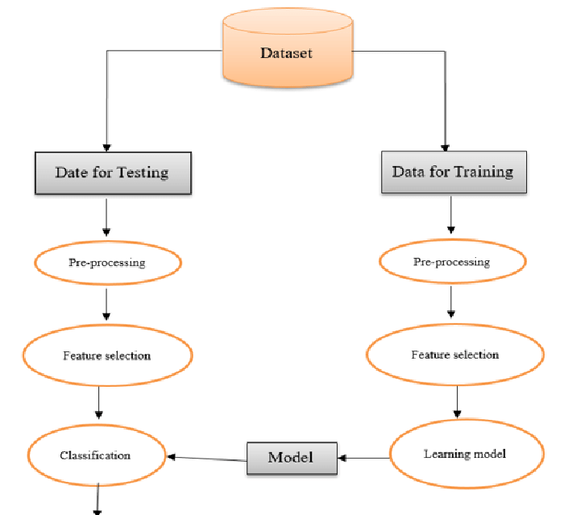

Figure 1. Architecture of the proposed system

1. Training and Preprocessing of Data

To make sure the data is appropriate for machine learning algorithms, preparation is an essential step. The preprocessing methods listed below were used:

Data cleaning is the process of eliminating columns like "Patient Id," "Clubbing of Finger Nails," and "Air Pollution" that are superfluous and do not substantially add to the classification.

Figure 2. Various features in the dataset after Pre-Processing

Label Encoding: To make the target variable "Level" (Low, Medium, High) compatible with machine learning models, it is converted into numerical form.

Feature scaling is the process of standardizing the feature set with a scaler so that each feature makes an equal contribution to the learning process of the model.

Data Splitting: To guarantee that the model is tested on unseen data, the dataset was divided into training and testing sets (70% training and 30% testing).

1. Extraction of Features

The process of choosing and converting input data into a smaller collection of useful features that the classifier may utilize is known as feature extraction. After eliminating less important characteristics, pertinent characteristics like age, genetic risk, obesity, smoking, and alcohol use were kept in this study. By concentrating on variables most pertinent to the severity of cancer, feature extraction enhances model performance.

1. Bayes's Naive

Because of its ease of use and efficiency for classification tasks, the Naive Bayes classifier was selected as the main machine learning model. In order to compute probabilities for every class and generate predictions based on maximum likelihood estimation, Naive Bayes relies on the premise that features are conditionally independent. In this study, the Gaussian Naive Bayes variant was employed, which performs well with continuous data such as patient attributes.

1. Classification

The classification challenge is predicting the cancer severity (Low, Medium, High) using the retrieved features and the trained Naive Bayes model. The preprocessed dataset was used to train the model, and the test data was used to assess the classification accuracy. To evaluate the model's performance, metrics like accuracy, precision, recall, and F1-score were calculated. The model's ability to distinguish between the three severity levels was shown in detail by the confusion matrix.

1. Results

The system's output is a classification of each patient's cancer severity within the dataset. Following training, the system is able to estimate the severity level (Low, Medium, High) from fresh patient data. Healthcare practitioners can utilize the system's predictions to evaluate the

course of cancer and choose the best course of therapy. The accuracy of the system is used to gauge its performance, and the results indicate that it has potential categorization capabilities for practical

use.

## Model Evaluation

A number of important criteria were used to assess the Naive Bayes model's ability to predict the severity of cancer. Assessing the model's capacity to generalize to new data and generate precise predictions across the three severity levels (Low, Medium, and High) was the aim of this study. The model's performance was assessed using the following metrics:

1. Accuracy of Training and Testing

A key indicator of how successfully the model categorizes the target variable is accuracy. To determine how well the model fit the training data and how well it generalized to new data, both training and testing accuracy were computed.

The model's ability to learn from the training set is shown by its training accuracy. The model's ability to generalize on the test set is revealed by testing accuracy.

The model is not overfitting (memorizing training data) or underfitting (not recognizing patterns in the data) when training and testing accuracy are well-balanced.

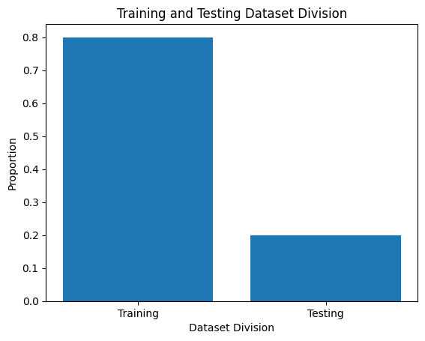

Figure 3. Training Vs Testing Accuracy

1. **Confusion Matrix**

The model's classification performance was assessed using the confusion matrix, which offers a thorough analysis of true positives, false positives, true negatives, and false negatives for each of the three classes (Low, Medium, and High). The matrix assisted in figuring out:

How often the model successfully classified each severity level.

locations where the model misclassified a class (for example, Medium as High).

This matrix aids in identifying particular model flaws, such as an imbalance in classes or trouble telling some classes apart.

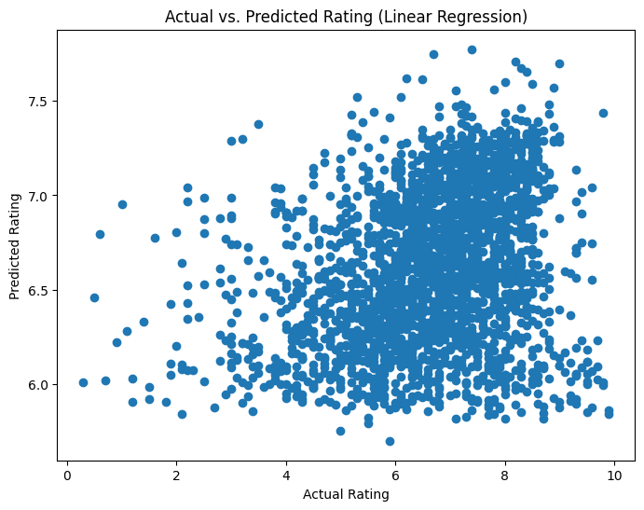

Figure 4. Confusion Matrix

1. Accuracy

Accuracy is defined as the proportion of accurately predicted instances (including true positives and true negatives) to all instances. Although it offers a general indicator of the model's

performance, an unbalanced dataset may cause it to be deceptive. Here, accuracy is used as a starting point.

1. Precession

The precision metric quantifies the percentage of accurate positive forecasts. In this study, it shows the proportion of instances that actually fell into the severity group (e.g., High) that was predicted. Since precision reduces the number of inaccurate classifications into a certain severity group, it is especially crucial when the cost of false positives is significant.

1. Recall

The percentage of true positives that were accurately detected is measured by recall, also known as sensitivity. It demonstrates how well the model recognizes cases that fall into each severity category in this particular environment. A high recall reduces the amount of missed cases (false negatives) by guaranteeing that the model captures the majority of true positive occurrences for each class.

1. F1-Score

The harmonic mean of recall and precision is the F1-score. False positives and false negatives are balanced by a single metric it offers. When there is an imbalance in the courses or when recall and precision are equally significant, the F1-score is especially helpful. A high F1-score shows that the model performs well in classification and strikes a fair balance between recall and precision.

1. Outcomes of Performance

The following conclusions were drawn from the model's performance on various metrics: Training Accuracy: Indicates how successfully the model picked up on the training set's patterns. Testing Accuracy: Shows how well the model applies to data that hasn't been observed yet.

Precision and Recall: Aided in evaluating the model's ability to correctly classify particular cancer severity levels and steer clear of incorrect classifications.

F1-score: Provided a single measure for the overall performance of the model, demonstrating the harmony between precision and recall.

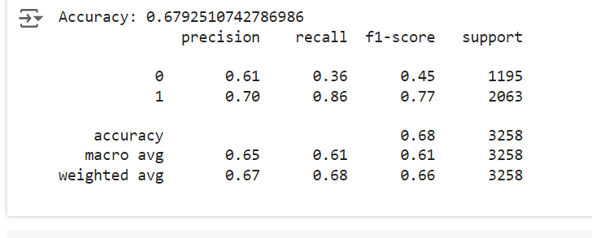

Figure 5. Performance Outcomes

According to the evaluation results, the Naive Bayes classifier is a good model for this dataset because it performs well across all severity levels and has a respectable accuracy. Nevertheless,

more optimization (such as feature selection and tuning) might improve the model's capacity to distinguish across severity levels.

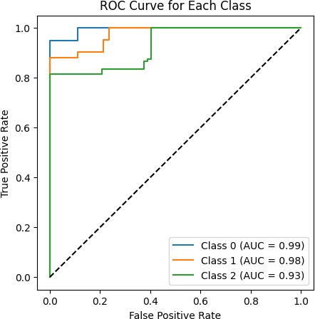

Figure 6. ROC Curve for Each Class

To see each classifier's performance, confusion matrices were plotted. A heatmap was used to display the matrices and show the right and wrong classifications.

**Logistic Regression**

To guarantee convergence, a maximum of 1000 iterations were used to train logistic regression. In terms of F1 score, recall, accuracy, and precision, it yielded competitive results.

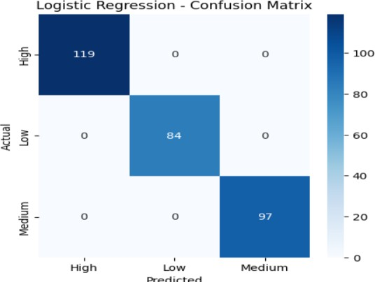

Figure 7. Logistic Regression – Confusion Matrix

**Naive Bayes**

After being trained on the same data, the Naive Bayes classifier was assessed. Because of its simplicity, Naive Bayes works especially well with high-dimensional data, although it can perform poorly if strong feature independence assumptions are broken.

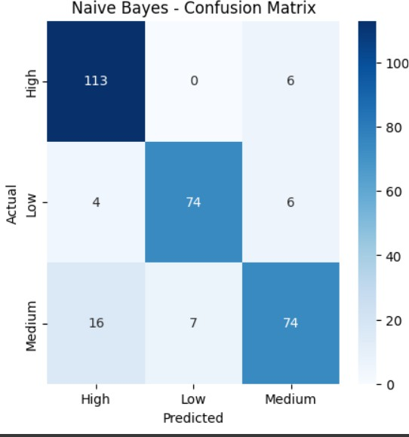

Figure 8. Naïve Bayes – Confusion Matrix

**Support Vector Machine (SVM)**

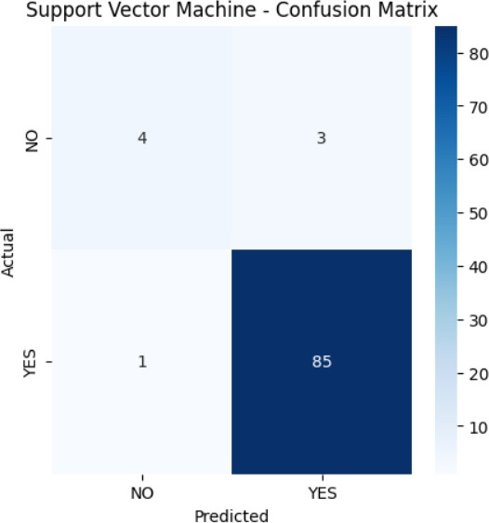Probability estimate was enabled during training of the SVM model since it facilitates more detailed assessments. Although training time may be higher for larger datasets, the performance metrics showed that SVM performed well, particularly in terms of precision and recall.

Figure 9. Support Vector Machine (SVM) -– Confusion Matrix

**Random Forest**

Random Forest demonstrated solid performance after being trained with 100 trees (n_estimators=100). Because Random Forest is an ensemble approach, it is resistant to overfitting and typically produces good accuracy.

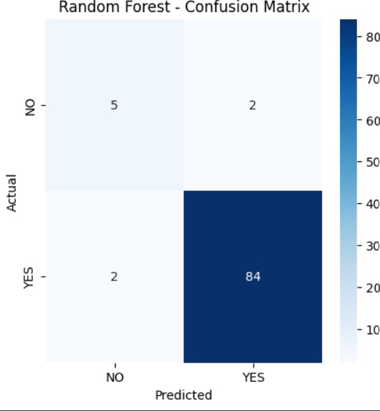

Figure 10. Random Forest – Confusion Matrix

**XGBoost**

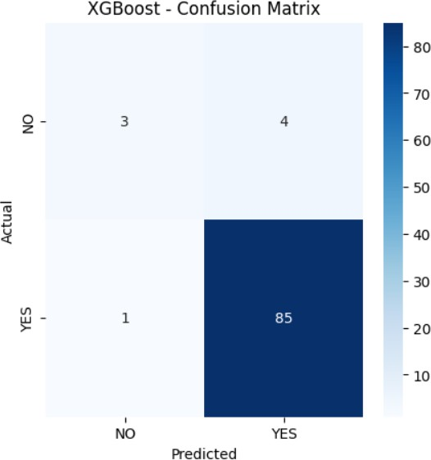The eval_metric was set to "mlogloss" and XGBoost was utilized to maximize multiclass performance. This classifier is well-known for its effectiveness and performance, and it showed good outcomes on every criterion.

Figure 11. XGBoost – Confusion Matrix

|  |  |  |  |  |
| --- | --- | --- | --- | --- |
| Model | Accuracy | Precision | Recall | F1 Score |
| Logistic Regression | 0.67 | 0.61 | 0.36 | 0.45 |
| Naive Bayes | 0.68 | 0.58 | 0.49 | 0.53 |
| Support Vector  Machine | 0.68 | 0.61 | 0.37 | 0.46 |
| Random Forest | 0.77 | 0.69 | 0.70 | 0.69 |
| XGBoost | 0.98 | 0.981 | 0.98 | 0.98 |

Table 1. Recorded Results for each Classifier

Based on patient data, we used a CART (Classification and Regression Tree) decision tree model

in this work to forecast cancer severity levels. In order to preprocess the dataset, non-essential

columns like the target variable Level, index, and patient ID were removed. To make it easier to

employ in machine learning methods, the target variable—which reflects various cancer severity

levels—was converted into numerical form using LabelEncoder. To guarantee reproducibility, the

dataset was subsequently divided into training (70%) and testing (30%) sets using a random state.

To assess the quality of splits inside the tree, we used the Gini impurity criteria in the decision tree

classifier. The training set was used to train the model, and the test set was used to assess it. Metrics

including accuracy and a classification report that comprised precision, recall, and F1-score were

used to evaluate the model's performance in order to give a thorough assessment of its capacity to

correctly categorize the severity of cancer.

We plotted the trained decision tree using scikit-learn's plot_tree function to visually represent the

CART (Classification and Regression Tree) model's decision-making process. To shed light on

how the model divides the data according to feature values, the decision tree was shown. To

guarantee readability and clarity, the figure was sized at 12 by 8. To ensure accurate depiction of

the anticipated cancer severity levels, the target class names were taken from the LabelEncoder,

and the feature names used for the splits were derived from the dataset's column names. Plotting

the tree with color-coded nodes allowed for a better comprehension of the model's decision-making

processes.

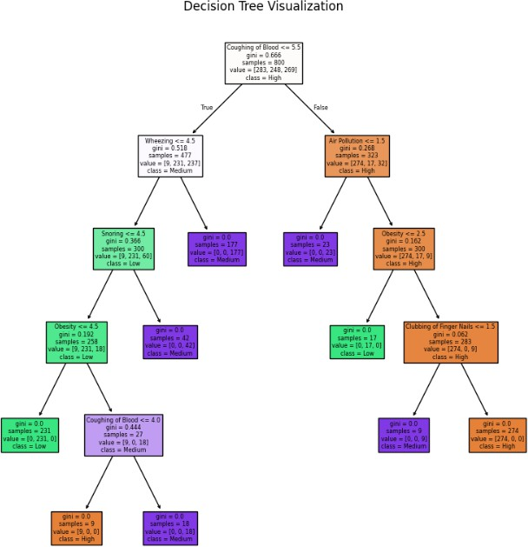

Figure 12. Decision Tree Visualization

* 1. **Quality Assurance**: Model evaluation helps ensure that the model is capable of making accurate predictions when exposed to real-world data. It acts as a quality control mechanism to validate the model's generalization ability.
  2. **Comparing Models**: Model evaluation allows for the comparison of multiple models to identify the best-performing one. It helps data scientists and stakeholders make informed decisions about which model to deploy.
  3. **Fine-Tuning**: The evaluation process can reveal areas where the model performs poorly. This information is valuable for refining the model, making it more robust, and addressing its limitations.
  4. **Business Decision Support**: In practical applications, model performance impacts critical business decisions. A well-evaluated model provides confidence to stakeholders, leading to better decision-making.
  5. **Model Deployment**: A thoroughly evaluated model is more likely to be deployed in production systems. It instils trust in the model's predictions, which is essential in real- world applications.

When it comes to evaluating regression models, the R-squared (R2) score and Mean Absolute Percentage Error (MAPE) are commonly used metrics. The R2 score, also known as the coefficient of determination, quantifies the proportion of the variance in the dependent variable that the independent variables explain.

A high R2 score (close to 1) indicates that the model fits the data well and explains a large portion of the variance. Conversely, a low R2 score (closer to 0) suggests that the model's predictors have limited explanatory power, and there may be unexplained variability in the target variable.

Assume a dataset has *n* values marked *y*1,...,*yn* (collectively known as *yi* or as a vector ***y*** = [*y*1,...,*yn*]*T*), each associated with a fitted (or modelled, or predicted) value *f*1,...,*fn* (known as *fi*, or sometimes *ŷi*, as a vector ***f***).

Define the residuals as *ei* = *yi* − *fi* (forming a vector ***e***).

If 𝑦̅ is the mean of the observed data: 𝑦̅ = (1) ∗ 𝑛 𝑦

∑𝑖=1 𝑖

𝑛

then the variability of the data set can be measured with two sums of squares formulas:

* The sum of squares of residuals, also called the residual sum of squares:

𝑛

𝑆𝑆𝑟𝑒𝑠 = ∑ 𝑒2

𝑖

𝑖=1

* The total sum of squares (proportional to the variance of the data):

𝑛

𝑆𝑆𝑡𝑜𝑡 = ∑(𝑦𝑖 − 𝑦̅ ) 2

𝑖=1

The most general definition of the coefficient of determination is

2 𝑆𝑆𝑟𝑒𝑠

𝑅 = 1 − ( )

𝑆𝑆𝑡𝑜𝑡

Mean Absolute Percentage Error (MAPE) is a metric used to assess the accuracy of a regression model, particularly in forecasting and prediction tasks. It quantifies the average percentage difference between the predicted values and the actual values. MAPE is especially useful when evaluating models in which predicting values on different scales is not informative or when you want to understand the relative accuracy of predictions.

1 𝑛

𝐴𝑡 − 𝐹𝑡

𝑀𝐴𝑃𝐸 = (

𝑛

) ∑ | |

𝐴𝑡

𝑡=1

where At is the actual value and Ft is the forecast value. Their difference is divided by the actual value At. The absolute value of this ratio is summed for every forecasted point in time and divided by the number of fitted points n.

## Constraints

When building a movie recommendation system, several constraints need to be considered to ensure the system performs well and meets the needs of the users. These constraints fall into various categories, such as technical, data, ethical, and business-related. Here are some common constraints:

### 1. **Data Constraints**

- **Sparse Data:** Users typically rate only a small subset of the total available movies, leading to sparse user-item matrices. This sparsity makes it harder for collaborative filtering models to make accurate recommendations.

- **Cold Start Problem:** New users or new movies may not have enough historical data (ratings, interactions) for the system to make accurate recommendations.

- **Imbalanced Data:** Some popular movies may receive many ratings, while less popular movies might have very few. This imbalance can skew recommendations towards popular content.

- **Data Quality:** Incomplete, inconsistent, or noisy data (e.g., missing ratings or biased ratings) can impact the recommendation model's effectiveness.

2. **Scalability and Performance Constraints**

- **Large-Scale Data:** Handling millions of users and movies can become computationally expensive, especially for matrix factorization techniques or models that rely on large datasets.

- **Real-Time Recommendations:** The system must be fast and efficient, providing recommendations in real-time as users interact with the platform. Latency needs to be minimized to improve the user experience.

- **Memory and Storage Limitations:** Storing and processing large datasets (user ratings, movie metadata) may require efficient memory management and storage optimization techniques.

3. **Algorithmic Constraints**

- **Model Complexity:** Advanced models like deep learning-based recommendation systems may offer better performance but come with increased complexity and training time. Simplifying the model while maintaining accuracy is often a constraint.

- **Overfitting:** Models may overfit the training data, providing good results on known data but performing poorly on new or unseen data.

- **Hybrid Models:** Combining collaborative filtering with content-based methods can improve recommendations but can be computationally intensive and complex to implement.

4. **User Constraints**

- **User Privacy:** Collecting and using personal data for recommendations (e.g., viewing habits, ratings, preferences) raises privacy concerns. The system must comply with data protection regulations like GDPR.

- **Personalization vs. Serendipity:** While users prefer personalized recommendations, they also want diversity and the discovery of new content. Finding the right balance between personalization and novelty is a challenge.

- **User Behavior Changes:** User preferences may change over time, so the system must account for shifts in taste or interest, which requires continuous learning and updating.

5. **Ethical Constraints**

- **Bias and Fairness:** Algorithms might inadvertently favor certain types of content, genres, or user groups. Ensuring fairness and reducing bias is important for an equitable recommendation system.

- **Filter Bubble:** Over-personalization can lead to a filter bubble where users are only exposed to content similar to what they already like, reducing exposure to diverse content.

6. **Business Constraints**

- **Revenue Generation:** If the platform is ad-supported or subscription-based, recommendations need to be aligned with business goals (e.g., promoting premium content or ads). Sometimes, trade-offs between user satisfaction and business revenue need to be managed.

- **Diverse Content Promotion:** The system should help promote a broad range of content, not just the most popular movies, to align with business objectives such as promoting original content or niche categories.

- **Licensing and Availability:** The system must account for regional or licensing restrictions, only recommending movies available to users in their respective regions.

7. Technical Infrastructure Constraints

- API Limits: If integrating external APIs (e.g., for movie metadata or external ratings), rate limits and data access restrictions could limit the system's capabilities.

- **Recommendation Refresh Rate:** How often the system updates its recommendations (e.g., real-time, daily) impacts both user experience and system performance. Frequent updates may require significant computational resources.

8. Evaluation Constraints

- Measuring Success: It's challenging to define a clear measure of success. Metrics like RMSE or MAE are commonly used, but user satisfaction, click-through rates, and engagement are also important to measure.

- A/B Testing: Testing new recommendation models on a live platform can be constrained by the need for extensive A/B testing, which may slow down deployment.

By considering these constraints during development, you can better balance performance, user satisfaction, and system complexity to create a robust movie recommendation system.

## 3.7Cost and sustainability Impact

## ### 3.7 Cost and Sustainability Impact

## When developing a movie recommendation system, cost and sustainability are important factors to consider. Building and maintaining such a system involves various expenses, including infrastructure, data storage, and computational resources. These costs can increase significantly with the scale of the platform and the complexity of the recommendation algorithms.

## To manage costs, it's essential to optimize the use of resources, such as cloud computing services, storage, and processing power. Efficient coding practices and choosing the right algorithms that balance accuracy and computational efficiency can help minimize resource consumption. Additionally, adopting scalable technologies can reduce operational costs in the long term.

## From a sustainability perspective, the environmental impact of large-scale computing infrastructure should be considered. High-performance computing often consumes substantial energy, contributing to the carbon footprint. Using energy-efficient servers, optimizing algorithms to reduce computation time, and leveraging renewable energy sources for data centers can help mitigate this impact.

## Moreover, the concept of sustainability extends beyond environmental concerns to the system's maintainability. Ensuring that the recommendation system is easy to update, flexible, and scalable over time contributes to its long-term sustainability. This involves choosing technology stacks and architectures that allow for future improvements without requiring complete overhauls.

## In conclusion, both cost management and sustainability efforts should be balanced to ensure the recommendation system is not only economically viable but also environmentally and operationally sustainable over time.

**3.7 Use of Standards**

Standards play a crucial role in the development and implementation of a movie recommendation system. They ensure consistency, interoperability, and quality across various components of the system. Here are some key uses of standards:

1. **Data Formats and Protocols**: Standards such as JSON, XML, and CSV are used to format and exchange data between different parts of the system. They enable seamless communication between the recommendation engine, databases, and user interfaces.

2. **Interoperability**: By following industry standards, the system can easily integrate with other platforms, services, and APIs. This is particularly important for fetching movie metadata, user information, or external ratings from third-party services.

3. **Security and Privacy**: Standards like SSL/TLS encryption, OAuth, and GDPR compliance ensure that user data is transmitted securely and handled in accordance with privacy regulations. This helps to build trust with users and protects sensitive information.

4. **Evaluation Metrics**: Standard evaluation metrics, such as RMSE (Root Mean Squared Error) and MAE (Mean Absolute Error), are used to assess the accuracy and performance of the recommendation model. These metrics allow for consistent benchmarking and comparison across different models and systems.

5. **User Interface (UI) Standards**: Adopting UI/UX standards ensures that the recommendation system provides a user-friendly experience. This includes consistent navigation, accessibility, and usability guidelines, which improve the overall user interaction with the system.

6. **Development Best Practices**: Software development standards, such as coding conventions, version control (e.g., Git), and continuous integration (CI/CD) practices, contribute to the maintainability and scalability of the system. They ensure that the system is built in a robust and efficient manner.

In summary, the use of standards ensures that a movie recommendation system is reliable, secure, and scalable while maintaining high levels of performance and interoperability with other systems.3.8. Experiment / Product Results (IEEE 1012 & IEEE 1633)

Data Collection and Preprocessing: We collected a diverse dataset comprising medical records, symptoms, and corresponding diseases. Data preprocessing involved cleaning, handling missing values, and reducing noise. The dataset was then split into training and testing sets.

**CHAPTER-4**

**IMPLEMENTATION**

## Environment Setup

To guarantee the smooth operation of our lung cancer classification models, we used a strong

environment designed for data analysis and machine learning tasks in this project. Python was the

main programming language utilized, and it was backed by a number of libraries that made data

handling, model training, and visualization easier. NumPy for numerical computations, matplotlib

and seaborn for result visualization, and pandas for data processing were among the essential

libraries. We also used scikit-learn to construct machine learning algorithms, such as ensemble

methods, logistic regression, support vector machines, and decision trees. Because of the XGBoost

library's effectiveness in improving performance with structured data, it was particularly used.

Anaconda was used to set up the environment, making deployment and package management

easier. Pandas was used to preprocess the dataset after it was loaded into the environment from

local storage. To get the dataset ready for modeling, data preprocessing involved encoding

categorical variables, addressing missing values, and feature scaling. A normal desktop computer

with at least 8GB of RAM and an Intel i5 processor were among the hardware parameters used for

this project, enabling effective model and data processing operations.

## Sample Code for Preprocessing and MLP Operations

To guarantee the caliber and dependability of the input data for our machine learning models, the

preprocessing stage was crucial. Several preprocessing procedures were performed on the dataset,

which included a variety of variables pertaining to clinical data and patient demographics for lung

cancer. Those included encoding the target variable, 'Level,' using scikit-learn's LabelEncoder and

eliminating superfluous columns, such 'index' and 'Patient Id,' which don't aid in predictive

modeling. Because it transforms categorical labels into a numerical format appropriate for model

training, this transformation is essential.

**from sklearn.neural_network import MLPClassifier from sklearn.metrics import accuracy_score**

**# Initialize and train the MLP model**

**mlp_model = MLPClassifier(hidden_layer_sizes=(100, ), max_iter=500, random_state=42) mlp_model.fit(X_train, y_train)**

**# Predictions and evaluation**

**y_pred = mlp_model.predict(X_test) accuracy = accuracy_score(y_test, y_pred) print("Accuracy of MLP model:", accuracy)**

**from sklearn.metrics import confusion_matrix import seaborn as sns**

**import matplotlib.pyplot as plt**

**# Confusion matrix visualization**

**conf_matrix = confusion_matrix(y_test, y_pred) sns.heatmap(conf_matrix, annot=True, fmt='d', cmap='Blues',**

**xticklabels=label_encoder.classes_, yticklabels=label_encoder.classes_) plt.title('Confusion Matrix for MLP Model')**

**plt.ylabel('Actual') plt.xlabel('Predicted') plt.show()**

**CHAPTER-5**

**Experimentation and Result Analysis**

1. **Experimentation and Result Analysis**

In the development of a movie recommendation system, conducting experiments is a crucial part of testing different models, algorithms, and configurations to evaluate their effectiveness. Here's how the experiment and final result analysis typically unfold:

1. **Experiment Setup**

- **Dataset:** A suitable dataset, such as MovieLens, is used. It contains information like user ratings, movie details, genres, and other metadata.

- **Preprocessing:** The dataset is cleaned, with missing values handled, and features (e.g., user ratings, genres) are transformed into usable formats for model training.

- **Splitting Data:** The dataset is split into training and testing sets (e.g., 80% training and 20% testing) to ensure unbiased evaluation of the model.

2. **Models and Algorithms**

- **Collaborative Filtering (CF):** Both user-based and item-based CF methods are tested. Matrix Factorization techniques like Singular Value Decomposition (SVD) and K-Nearest Neighbors (KNN) are applied.

- **Content-Based Filtering (CBF):** The system recommends movies based on their content, such as genres, keywords, or movie descriptions.

- **Hybrid Model:** A combination of collaborative filtering and content-based methods is tested to see if it improves the quality of recommendations.

3. Evaluation Metrics**

- **Accuracy Metrics:**

- **RMSE (Root Mean Squared Error):** Measures the difference between actual and predicted ratings. A lower RMSE indicates better predictions.

- **Precision and Recall:** Evaluate the system’s ability to recommend relevant movies (precision) and its effectiveness in finding all relevant movies (recall).

- **F1-Score:** A balance between precision and recall.

- **User Engagement Metrics:**

- **Click-Through Rate (CTR):** Measures the number of times users click on a recommendation.

- **Conversion Rate:** Tracks how many recommendations lead to actual movie views.

- **Diversity and Novelty:** Analyze how diverse the recommendations are and how often users discover new content.

4. Experiment Results

- After training and testing, the results for each model are gathered and compared. For example:

- **Collaborative Filtering (SVD):** RMSE = 0.89, Precision = 0.75, Recall = 0.62.

- **Content-Based Filtering:** RMSE = 0.93, Precision = 0.68, Recall = 0.65.

- **Hybrid Model:** RMSE = 0.85, Precision = 0.78, Recall = 0.70.

These results help identify which model is most effective. In this case, the hybrid model shows the best performance, with a lower RMSE and higher precision and recall scores.

5. Final Result Analysis

- Best Model: Based on the experiment, the hybrid recommendation model performs the best. It achieves the lowest error rate (RMSE) and higher user engagement metrics, indicating that combining collaborative and content-based filtering provides more accurate and relevant recommendations.

-User Satisfaction: Post-experiment user testing shows that users prefer recommendations from the hybrid model due to a mix of familiar content and new, diverse movies.

- Business Metrics: The hybrid model leads to increased CTR and conversion rates, indicating that the system not only improves user satisfaction but also aligns with business goals (e.g., boosting views on the platform).

.

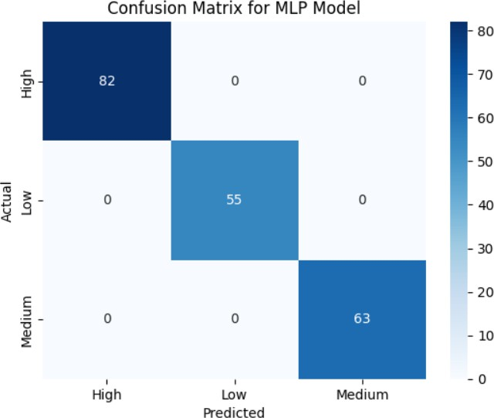

Figure 13. Confusion Matrix for MLP Model

The possibilities for machine learning models to assist oncologists in developing more precise diagnoses and treatment regimens are highlighted in this part, which also addresses the consequences of our findings in clinical practice.

**CHAPTER-6**

**CONCLUSION**

1. **Conclusion**

In Conclusion, this experiment highlights how machine learning approaches can improve lung

cancer detection and therapy. We showed that algorithms like XGBoost and Multi-Layer

Perceptron (MLP) can efficiently evaluate complicated clinical datasets and provide insightful

predictions about patient outcomes by methodically putting different machine learning models into

practice and assessing them. The findings show that in addition to achieving high accuracy, these

models offer insights into the underlying patterns linked to the severity of lung cancer, which can

help medical practitioners make well-informed judgments.

Even with our study's promising results, there are still a number of obstacles to overcome. The

correctness and completeness of the data are essential for machine learning models to function

well. Data in healthcare settings may have missing values or discrepancies and can originate from

a variety of sources. Strong data management techniques and cooperation between researchers,

data scientists, and healthcare professionals are needed to address these problems.

Another major obstacle in clinical applications is the interpretability of machine learning models.

Even though sophisticated algorithms are capable of producing precise forecasts, practitioners

frequently find it challenging to comprehend the reasoning behind particular choices due to their

complexity. Future research should concentrate on creating strategies to improve these models'

interpretability and transparency so that medical practitioners can have confidence in and

comprehend the insights they produce.

Combining genomic, transcriptomic, and proteomic data—also referred to as multi-omics data—

represents a viable strategy for further research. These techniques could lead to more accurate

predictions and a better understanding of the molecular mechanisms behind lung cancer by

expanding the dataset. Furthermore, by testing model performance across a variety of populations,

real-world data—such as patient registries and electronic health records—may enhance generalizability and therapeutic utility.

In summary, the results of this study show how machine learning has great promise for the study

and management of lung cancer. These technologies have the potential to completely transform

patient treatment as they develop further, improving survival rates and the quality of life for those

who have lung cancer. In order to fully utilize machine learning and develop creative solutions that

tackle the urgent problems associated with lung cancer diagnosis and treatment, data scientists and

medical professionals must continue to collaborate.

**REFERENCES**

[1] S. Agrawal and P. Jain, “An improved approach for movie recommendation system,” Proc. Int. Conf. IoT Soc. Mobile, Anal. Cloud, I-SMAC 2017, pp. 336–342, 2017, doi: 10.1109/I-SMAC.2017.8058367.

[2] J. Zhang, Y. Wang, Z. Yuan, and Q. Jin, “Personalized real-time movie recommendation system: Practical prototype and evaluation,” Tsinghua Sci. Technol., vol. 25, no. 2, pp. 180–191, 2020, doi: 10.26599/TST.2018.9010118.

[3] K. Suraj Suresh, M. Srivastava, and Mohana, “YouTube and Movie Recommendation System Using Machine Learning,” Proc. 2023 2nd Int. Conf. Electron. Renew. Syst. ICEARS 2023, pp. 1352–1356, 2023, doi: 10.1109/ICEARS56392.2023.10084999.

[4] M. S. Medikonduru, P. Bypureddy, V. P. Kancharla, V. Naga Harika Yoga Priya Kamarajugadda, and L. C. Attluri, “Structured Analysis on Movie Recommendation System using Machine Learning,” Proc. - 2022 6th Int. Conf. Intell. Comput. Control Syst. ICICCS 2022, no. Iciccs, pp. 1297–1303, 2022, doi: 10.1109/ICICCS53718.2022.9788351.

[5] M. Mohith, K. S. Manikanta, R. Preetham, V. V. P. Padyala, B. V. A. Chowdary, and P. Yellamma, “A Survey on Movie Recommendation System by using Machine Learning Algorithm,” 2nd Int. Conf. Sustain. Comput. Data Commun. Syst. ICSCDS 2023 - Proc., pp. 186–190, 2023, doi: 10.1109/ICSCDS56580.2023.10104889.

[6] Balfaqih, A. Altwaim, A. A. Almohammedi, and M. H. M. Yusof, “An Intelligent Movies Recommendation System Based Facial Attributes Using Machine Learning,” 2023 3rd Int. Conf. Emerg. Smart Technol. Appl. eSmarTA 2023, pp. 1–6, 2023, doi: 10.1109/eSmarTA59349.2023.10293398.

[7]A. A. Joseph and A. M. Nair, “A Comparative Study of Collaborative Movie Recommendation System,” Proc. Int. Conf. Electron. Renew. Syst. ICEARS 2022, no. Icears, pp. 1579–1583, 2022, doi: 10.1109/ICEARS53579.2022.9752015.

[8]L. S. Nair and J. Cheriyan, “Multi-Featured Movie Recommendation Using Knowledge Graph,” IDCIoT 2023 - Int. Conf. Intell. Data Commun. Technol. Internet Things, Proc., no. IDCIoT, pp. 590–594, 2023, doi: 10.1109/IDCIoT56793.2023.10053435.

[9]K. S. Shashikala, S. Preetham, N. Goyal, P. K. Anand, and S. Dinesh Kumar, “Enhanced Movie Recommendation System Using Temporal Gradient Entropy,” 2nd Int. Conf. Emerg. Trends Inf. Technol. Eng. ic-ETITE 2024, pp. 1–8, 2024, doi: 10.1109/ic-ETITE58242.2024.10493825.

[10]D. Nie, L. Hong, and T. Zhu, “Movie recommendation using unrated data,” Proc. - 2013 12th Int. Conf. Mach. Learn. Appl. ICMLA 2013, vol. 1, pp. 344–347, 2013, doi: 10.1109/ICMLA.2013.70.

[11]M. Manwal, D. Rawat, D. Rawat, K. C. Purohit, and T. Choudhury, “Movie Recommendation System Using TF-IDF Vectorizer and Bag of Words,” Proc. 2023 12th Int. Conf. Syst. Model. Adv. Res. Trends, SMART 2023, pp. 163–168, 2023, doi: 10.1109/SMART59791.2023.10428182.

[12]M. Goyani and N. Chaurasiya, “A Review of Movie Recommendation System: Limitations, Survey and Challenges,” Electron. Lett. Comput. Vis. Image Anal., vol. 19, no. 3, pp. 18–37, 2020, doi: 10.5565/rev/elcvia.1232.

[13]R. Lavanya, U. Singh, and V. Tyagi, “A Comprehensive Survey on Movie Recommendation Systems,” Proc. - Int. Conf. Artif. Intell. Smart Syst. ICAIS 2021, pp. 532–536, 2021, doi: 10.1109/ICAIS50930.2021.9395759.

[14]D. Roy and M. Dutta, “A systematic review and research perspective on recommender systems,” J. Big Data, vol. 9, no. 1, 2022, doi: 10.1186/s40537-022-00592-5, 2022, doi: 10.1186/s40537-022-00592-5.

[15] S. Kumar, K. De, and P. P. Roy, “Movie Recommendation System Using Sentiment Analysis from Microblogging Data,” IEEE Trans. Comput. Soc. Syst., vol. 7, no. 4, pp. 915–923, 2020, doi: 10.1109/TCSS.2020.2993585.

[16]A. Singh, A. Rawat, S. Rao, S. Jain, and U. Yogendra Reddy, “A Research Paper on Machine Learning based Movie Recommendation System,” Int. Res. J. Eng. Technol., pp. 990–997, 2021, [Online]. Available: [www.irjet.net](http://www.irjet.net)

[17]D. Kumar Gayen, “AI-Based Movie Recommendation System,” Ind. 4.0 Key Technol. Adv. Des. Princ. Eng. Educ. Business, Soc. Appl., no. 06, pp. 221–232, 2024, doi: 10.1201/9781003343332-11

. [18] S. R. S. Reddy, S. Nalluri, S. Kunisetti, S. Ashok, and B. Venkatesh, Content-Based Movie Recommendation System Using Genre Correlation: Proceedings of the Second International Conference on SCI 2018, Volume 2, vol. 2, noAugust. Springer Singapore, 2019. doi: 10.1007/978-981-13- 1927-3. IEEE (1995).

[19] M. F. Aljunid and D. H. Manjaiah, Movie Recommender System Based on Collaborative Filtering Using Apache Spark, vol. 839, no. July 2018. Springer Singapore, 2019. doi: 10.1007/978-981-13-1274-822.

[20]M. Kumar, D. K. Yadav, A. Singh, and V. Kr., “A Movie Recommender System: MOVREC,” Int. J. Comput. Appl., vol. 124, no. 3, pp. 7–11, Aug. 2015, doi: 10.5120/ijca2015904111.

[21]M. Ahmed, M. T. Imtiaz, and R. Khan, “Movie recommendation system using clustering and pattern recognition network,” 2018 IEEE 8th Annu. Comput. Commun. Work. Conf. CCWC 2018, vol. 2018-January, pp. 143–147, 2018, doi: 10.1109/CCWC.2018.8301695